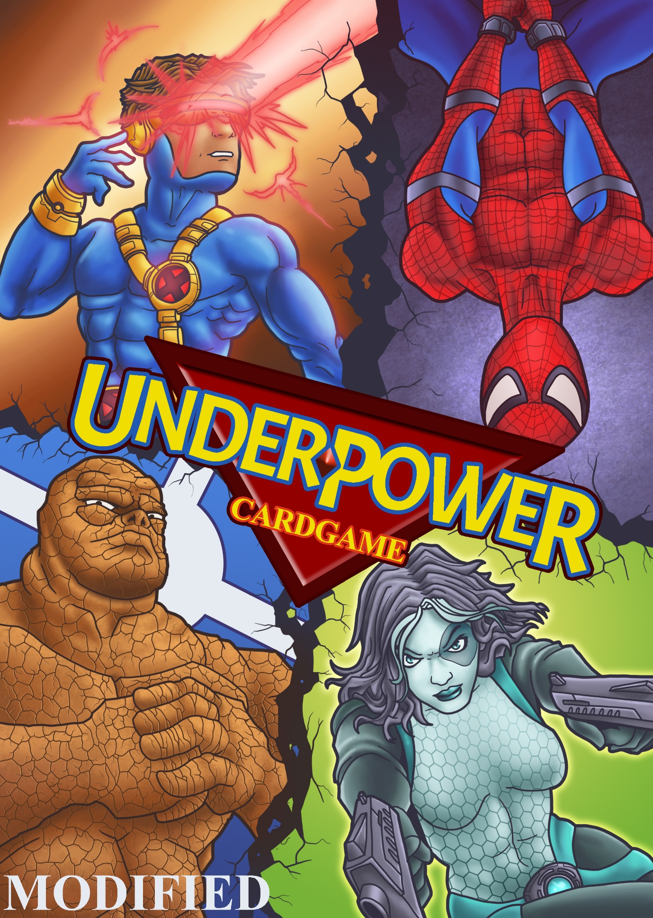

Polydina Flynt

Contact: http://polydina.com

Files: https://github.com/PolydinaF/underpower-rolly-polly

Details

Players take turns attacking each other, they do this using the cards in their hand. Each player starts with a portion of the deck (a third or half of the deck, depending on whether there are two or three players) as their hand. **(requires cards from the Marvel: Overpower card game)**

Game Mod: “Underpower” (for dummies)

*A Mod of the Marvel: Overpower card game for 2-3 Players*

**Game Mod: “Underpower” (for dummies)**

**2-3 Players**

**Game Details**

Players take turns attacking each other, they do this using the cards in their hand. Each player starts with a portion of the deck (a third or half of the deck, depending on whether there are two or three players) as their hand.

There are three types of cards that they can use to attack. The cards that they can attack with are: character cards, character cards with object cards, or character cards with action cards. Action cards can also be played individually. They can only use one or one pair per attack.

The game also has mission cards and mission cards are wild cards.

Wild Card means it’s an exception to the rules. Missions are special cards that win a play, because they deal unblockable full damage for one attack.

But you must have three of a kind to play the mission cards, you play all three in one attack then remove them from the game.

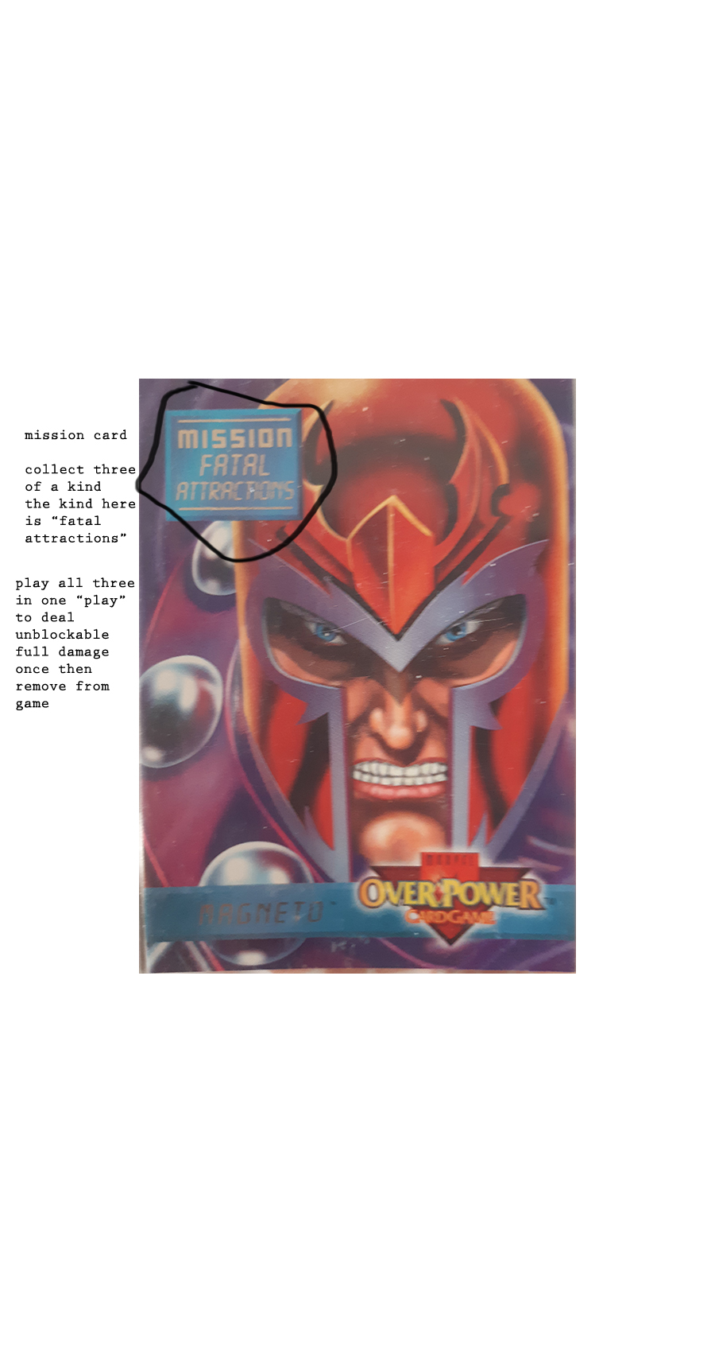

**Turn Phases**

Each attack is called a “play”; there are six plays in each sequence, at the end of the sequence someone has to pick up, a sequence ends early if a loser decides to pick up before reaching six plays.

A character card is the main type of card. It has a picture of a character from the Marvel Universe, the name of the character in small type and at least two numbers. The type of the number is an object which contains the number; an orange fist – for the “fighting” value of attack, a green anchor – for the “strength” value (the weakest value) of attack and/or (if there is more than one type you can choose which to use, you should choose the strongest type), a yellow star – for the ”energy” value (the strongest value) of attack. The highest value of attack wins the play if the numbers are the same. If the numbers are not the same, then the highest number wins the play. Losing the play if it was your turn to attack does nothing. Losing the play if it was your turn to defend means you were damaged, but if it is before the 6th play you can choose to keep going, or to pick up the number of cards equal to the number of damage you were dealt. Damage amount is equal to the number on the card that successfully attacked you. Or all of the cards in the discard pile if it is smaller than that amount.

**Character Cards**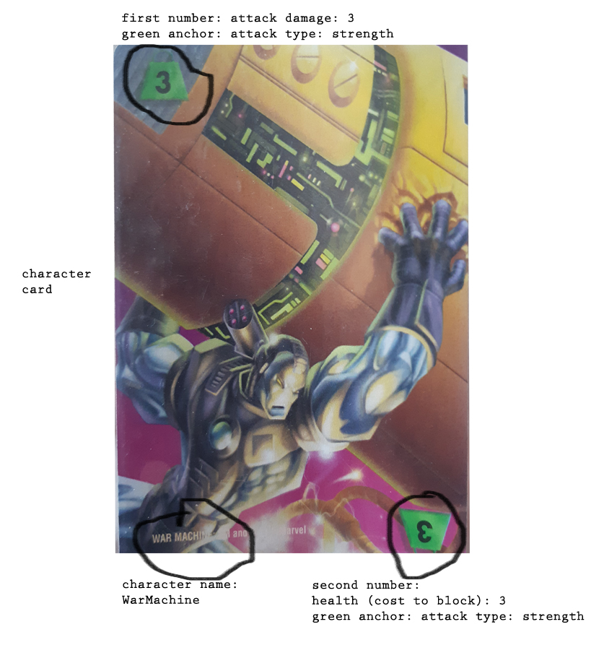

**What does “cost to block” mean?**

*This character can block upto their second number worth of damage if it is the user’s turn to defend (rather than attack) In this case they can block upto 3 damage, if they are dealt more than 3 damage, then they lose this play and character is destroyed (goes in the discard pile.) The amount of cards to pick up is equal the total damage dealt to them in this play. The number on the card or card combination that is used to attack them. They don’t have to pick up if it is before the sixth play.*

Non-character cards are the other type of card.

These are objects (no border), actions (yellow border) and missions (“mission” is part of the card text.)

Objects are used at the same time as a character (must be used with a character), but any character can be used with any object. Objects are discarded after use. Characters are not, unless they are dealt damage equal to their health therefore are destroyed.

Actions must be used with the designated character (written on the action card.) or can be used without a character for the smallest number of attack damage.

**Object Cards**

On the next page is an image of an Object card (no border)

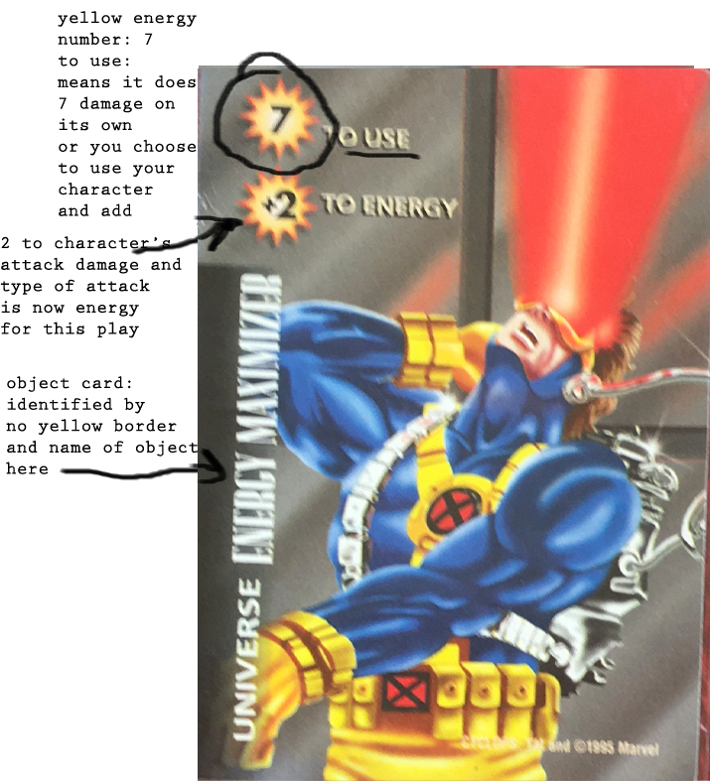

Missions can only be used when you have three of a kind and are like a wild card, you use all three in one play, and it is total damage and unblockable (i.e. instant win of that play)

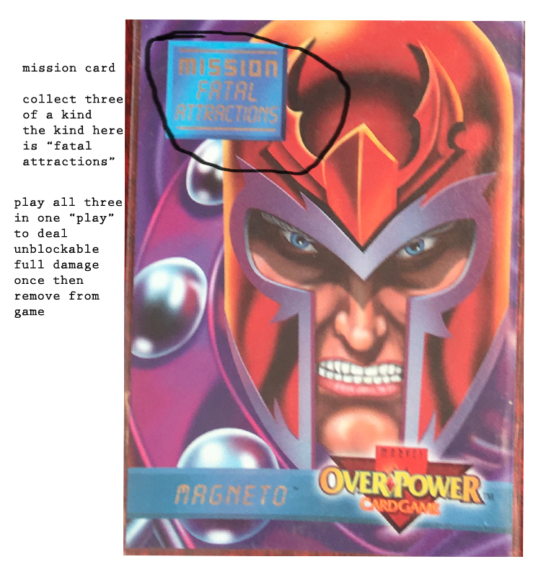

**What is the value of winning a play vs losing a play vs blocking a play?**

A successful block means not receiving damage (no-one picks up cards)

A successful attack where it is your turn to attack and your damage is higher than their health, is a win of the play (they pickup or choose to continue if it has been less than six plays)

**Action Cards**

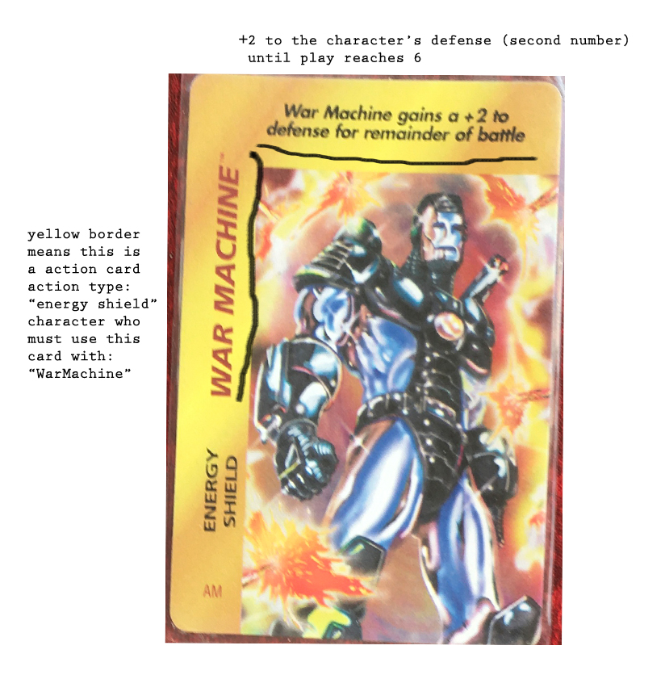**Below is an image of an Action card (yellow border)**

**Turn Phases - Continued**

A hand ends, when all players have reached six PLAYS.

A play = playing a card. Each player can play 1 card (or a pair or three in one go; for missions, or combining character with action/object.)

The loser of each play gets to decide whether to continue plays,

Or end the hand and pick up designated cards from the discard pile.

The final loser is the loser of the sequence and they are the only one who has to pick up cards from the discard pile. They pick up how many = to how much damage was dealt to them in the last play.

The game ends when all but one player has no cards in their hand.

The winner is the first player to get to this point.

If there is no loser in the current play, continue taking turns playing cards.

If you get to 6 plays and there is no loser, then remove the discard pile from the game and advance to the next sequence with a play count of 0.

If there are no cards in the discard pile, play continues with the cards in players’ hands.

**How to use the cards**

**Characters with more than one type of damage/health**

*Need to fill this in*

**Character Cards**

1st number = damage dealt

2nd number = health

Characters are played as attacks or defensive action.

Response: equal to or greater than health number in order to cancel the card from dealing damage to the player. (Doesn’t have to be the same type of power, but does need to be equal or greater than type of power VALUE. Values: 1. Energy, 2. Fighting, 3. Strength. Energy is the strongest power type in value.)

If not cancelled, the character remains in play until destroyed. Able to, if controller player chooses, deal its damage to opponent’s cards each play.

If a character is successfully blocked, it is considered discarded. Even with an object or action card used together with it.

**Action cards (yellow border)**

1st number = damage dealt

2nd number = damage defense

Venture total = damage number/s

Duration of battle = 6 plays

Player is required to have the named character in play and under their control in order to play actions. Actions are destroyed after play. Actions can be cancelled with equal or stronger force card of any type. Or by destroying the character, even after action is played.

Played together with character only – Character with action either as attack or defensive or special ability full damage, or addition to the character’s damage.

**Objects (no border)**

Objects are played individually as attack or defense single use, then discarded.

Or a character can use an object (any character can use any object) – Character with object either as attack or defensive or special ability full damage, or addition to the character’s damage.

**Missions**

Missions are played when you have three of a kind.

Successful mission (three of a kind played in one play) = total damage for 1 play (unblockable except by another successful mission)

**Card List**

(do not use horizontal character cards)

At least 62 cards for 2-3 players: (distributed evenly)

Characters:

War Machine 2

Nightcrawler 3

Longshot 3

Black Widow

Professor X

Cyclops 2

Storm 2

Century 5

Archangel 3

Sauron 4

Blackcat 2

Super Skull

Maxxed-out Super Skrull

Iron Man

Domino

Nebula

Electro 5

Objects/Actions:

Power Lines 2

Energy Booster

Energy Maximizer 2

Divine Intervention

Power Cosmic

Generator 2

Alien Technology

Hunk of Asphalt

Laser Pistol

Tree

Missions:

Fatal Attractions 3

Infestation Incident 3